**Software Requirements Specifications (SRS)**

**ERP Solution for Lakhsma Sweater Ltd.**

REFERENCE: GW/ERP/SRS/

**Version: 1.0**

**Date of Release: March 16, 2016**



**Genweb2 Limited**

TK Bhaban (11th Floor),

13 Kazi Nazrul Islam Avenue,

Kawran Bazar, Dhaka 1215, Bangladesh

web: [http://www.genweb2.com](http://www.genweb2.com/)

**Contents**

Document Release History 5

1.0 Introduction 6

1.1 Purpose of SRS 6

2.0 Human Resource Management & Payroll System 7

2.1 Overview 7

2.2 A Modern Approach to HR 7

2.3 Functions of HRMS Systems 7

2.4 Functional features of Human Resource Management System modules are given below. 7

2.5 Human Resource Management System Process flow 8

2.6 User Class 9

3.0 HR & Payroll Process Flow: 10

3.1 HR & Payroll Process details: 11

4.0 USE CASE Diagram 12

4.1 Employee Recruitment Process 12

4.2 Employee Separation process: 12

4.3 Shift Maintain Process: 13

4.4 Holiday Maintain Process: 13

4.5 Leave Maintain Process: 14

4.6 Absenteeism Maintain Process: 14

4.7 Late Present Maintain Process: 15

4.8 Disciplinary Action Process: 15

4.9 Attendance Bonus Process: 16

4.10 Festival Bonus Process: 16

4.11 Performance Bonus Process: 17

4.12 Appraisal Process: 17

4.13 Employee Blacklisting Process: 18

4.14 Salary Process: 18

5.0 USE CASE Details 19

5.1 UC/HRMS/001/Declaration of Departments & Sections: 19

5.2 UC/HRMS/002/Declaration of Position: 20

5.3 UC/HRMS/003/Declaration Of Organogram: 21

5.4 UC/HRMS/004/ Employee Type Declaration: 22

5.5 UC/HRMS/005/ Employee Recruitment Policy: 22

5.6 UC/HRMS/006/ Employee Separation Policy: 23

5.7 UC/HRMS/007/ Shift Planning: 24

5.8 UC/HRMS/008/ Declare Weekend & Holiday Policy: 25

5.9 UC/HRMS/009/ Declare Leave Rule & Policy: 26

5.10 UC/HRMS/010/ Declare absenteeism Policy: 27

5.11 UC/HRMS/011/ Declare Overtime Policy: 28

5.12 UC/HRMS/012/ Declare Late Policy: 29

5.13 UC/HRMS/013/ Disciplinary Action Policy: 30

5.14 UC/HRMS/014/ Declare Pay Grade: 31

5.15 UC/HRMS/015/ Declare Grade Step: 32

5.16 UC/HRMS/016/ Declare Pay Band: 33

5.17 UC/HRMS/017/ Declare Attendance Bonus Policy: 34

5.18 UC/HRMS/018/ Record Employees Personal Information: 35

5.19 UC/HRMS/019/ Tagging Employee to Department & Section: 36

5.20 UC/HRMS/020/ Declare Position to Employee: 37

5.21 UC/HRMS/021/ Tagging Shift to Employee: 38

5.22 UC/HRMS/022/ Tagging Holiday Policy to Employee: 39

5.23 UC/HRMS/023/ Tagging Leave Rule to Employee: 40

5.24 UC/HRMS/024/ Tagging absenteeism Policy to Employee: 40

5.25 UC/HRMS/025/ Tagging Overtime Policy to Employee: 42

5.26 UC/HRMS/026/ Tagging Late Policy to employee: 43

5.27 UC/HRMS/027/ Tagging Attendance Bonus policy to Employee: 43

5.28 UC/HRMS/028/ Tagging Festival Bonus policy to Employee: 45

5.29 UC/HRMS/029/ Tagging Performance Bonus policy to Employee: 46

5.30 UC/HRMS/030/ Plan Appraisal for Employee: 47

5.31 UC/HRMS/031/ Employee Separation: 48

5.32 UC/HRMS/032/ Blacklisting Employee: 48

5.33 UC/HRMS/033/ Process Salary: 49

6.0 HRMS mock-up 51

6.1 HRMS master user interface mock-up 51

6.1.1 Declare Departments: 51

6.1.2 Define Job Position: 51

6.1.3 Appraisal Plan: 52

6.1.4 Define Leave Policy: 52

6.2 Production Planning Operational user interface mock-up 53

6.2.1 Employee Basic Information 53

6.2.2 Employee Personal Information 53

6.2.3 Employee HR policy Tagging 54

Document Release History

| Sl. No. | Version Number | Release Date | Prepared By | Reviewed By | Approved By | Reasons for New Release |
| --- | --- | --- | --- | --- | --- | --- |
| 1 | 1.0 | 16 March, 2016 | Md. Assalatuzzaman |  | N/A |  |

# Introduction

## Purpose of SRS

The purposes of this SRS are to clearly identify the customer requirements and provide a detailed document. The customer will review the document and approve/make change as required. It will also help the review team to be able to validate whether the customer requirements has been fulfilled.

The SRS will also help the Analyst and Designer to understand and track the Requirements for the proposed system. It will also identify a set of requirements for the Development of the project. The SRS helps to describe the behavior of the system to be developed.

# Human Resource Management & Payroll System

## Overview

A HRMS (Human Resource Management System) is a combination of systems and processes that connect human resource management and information technology through HR software. A HRMS may help to revolutionize a workplace. The automation of repetitive and time consuming tasks associated with human resources management frees up some of the companies most valuable employees and allows the focus to shift to culture, retention, and other highly impactful areas.

## A Modern Approach to HR

Selecting a HRMS to handle HR activities is a trademark of the modern company, there are few successful companies in any industry that do not have some sort of automation in place for HR tasks at this juncture. Mobile accessibility has further worked to transform the landscape of HR, putting information and task management at the fingertips of employees and managers. HRMS has helped to effectively break down bureaucracy and “flatten” many organizations.

## Functions of HRMS Systems

The function of the human resources department involves tracking employee histories, skills, abilities, salaries, and accomplishments. Replacing certain processes with various levels of HRMS systems can distribute information management responsibilities so that the bulk of information gathering is not delegated strictly to HR. By allowing employees to update personal information and perform other tasks, information is kept more accurate and HR professionals are not bogged down.

## Functional features of Human Resource Management System modules are given below.

* [Managing payroll](http://www.hrpayrollsystems.net/payroll-systems/)
* [Recruitment and onboarding](http://www.hrpayrollsystems.net/consider-recruitment-features-when-selecting-an-hris/)
* Gathering, storing, and accessing employee information
* [Keeping attendance records](http://www.hrpayrollsystems.net/time-and-attendance-software/) and tracking absenteeism
* Leave Management
* Holiday Management
* [Performance evaluation](http://www.hrpayrollsystems.net/implementing-performance-review-software/)
* [Benefits administration](http://www.hrpayrollsystems.net/hris-benefits-administration/)
* [Learning management](http://www.hrpayrollsystems.net/learning-management-system/)
* [Employee self-service](http://www.hrpayrollsystems.net/employee-self-service/)
* [Employee scheduling](http://www.hrpayrollsystems.net/employee-scheduling-software-benefits/)
* Analytics and informed decision making

## Human Resource Management System Process flow

Human Resource Management System process flow consists:

* Define Employee Recruitment Policy
* Define Shift Policy
* Define Weekend Policy
* Define Holiday Policy
* Define Leave Policy
* Define Absenteeism Policy
* Define Late Policy
* Define Disciplinary Action Policy
* Define Attendance Bonus Policy
* Define Festival Bonus Policy
* Define Performance Bonus Policy
* Define Appraisal
* Record Employee Personal Information
* Define Applicable policies to Employee
* Process Salary
* Separate Employee
* Blacklisting Employee

## User Class

| **User Class / Actor** | **Characteristics** | **Responsibilities** |
| --- | --- | --- |
| HR Executive | * Add, modify Employee Information * Add, modify attendance * Add, modify Salary Process | * Add, modify documents * Maintain other documents related information |
| HR Manager | * Add, modify Recruitment Policy * Add, modify Separation Policy * Add, modify Shift Policy * Add, modify Holiday Policy * Add, modify Leave Policy * Add, modify Absenteeism Policy * Add, modify Late Present Policy * Add, modify Disciplinary Action Policy * Add, modify Attendance Bonus Policy * Add, modify Festival Bonus Policy * Add, modify Performance Bonus Policy * Add, modify Appraisal Policy * Add, modify Employee Blacklisting * Approve Processed Salary | * Add, modify documents * Maintain other documents related information |
| Super admin | * Can do any jobs in system | * Add, modify and delete all information. * Give permission to all users and documents. * Manage the user authentication layer. * Create & assign role to users. * Manage application security. * Manage application settings. |

# HR & Payroll Process Flow:

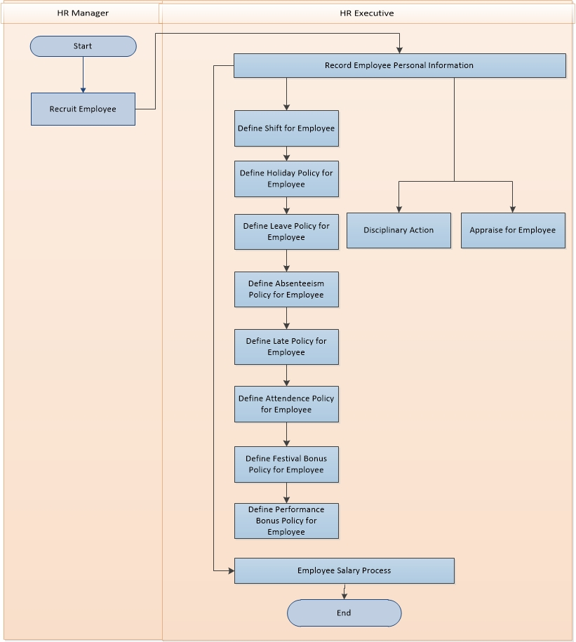

Fig: Production Planning Process

## HR & Payroll Process details:

**Configuration:**

**Define Employee Recruitment Policy:** Employee Recruitment policy will be defined here

**Define Shift Policy:** All active organization Shift Will be declared here along with the shift duration

**Define Holiday Policy:** All General and group wise holiday will be declared in organizational calendar in this process

**Define Leave Policy:** All Type of Leave will be declared here in this process along with the policies and applicability

**Define Absenteeism Policy:** All Type of Absenteeism criteria and adjustment will be declared here in this process

**Define Late Policy:** All Type of Late criteria and adjustment policy will be declared here in this process

**Define Disciplinary Action Policy:** All Type of Disciplinary Action Policy will be declared here in this process

**Define Attendance Bonus Policy:** All Attendance Bonus Criteria will be declared here in this process along with the policy.

**Define Festival Bonus Policy:** All Festival Bonus Criteria will be declared here in this process along with the policy.

**Define Performance Bonus Policy:** All Performance Bonus Criteria will be declared here in this process along with the policy.

**Define Appraisal:** Appraisal Plan will defined here in this process.

**Record Employee Personal Information:** All information of the Employee will be recorded here in the process. Employee’s Basic Information, Personal Information will be recorded here in this process.

**Define Applicable policies to Employee:** All HR policies configuration will be done over here in this process and Employee HR and Payroll will be process based on these tagged policies.

**Process Salary:** Employee’s Salary will be process in this process based on the tagged policies.

**Separate Employee:** Employee Separation from organization will be managed here in this process

**Blacklisting Employee:** If any Employee is needed to be declared as blacklisted for re-recruitment that will be declared here in this process.

# USE CASE Diagram

## Employee Recruitment Process

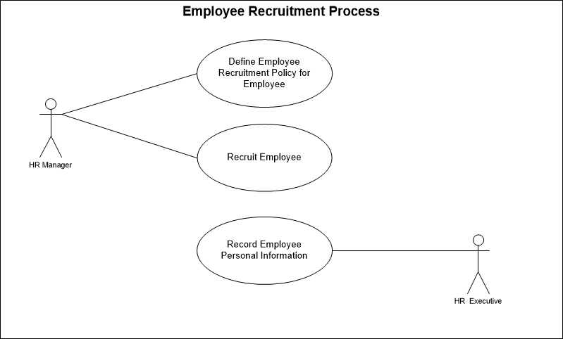

Fig: Employee Recruitment Process use case

## Employee Separation process:

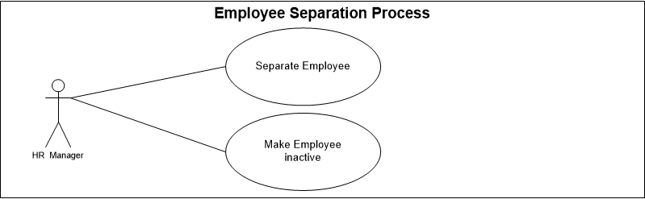

Fig: Employee Separation Process use case

## Shift Maintain Process:

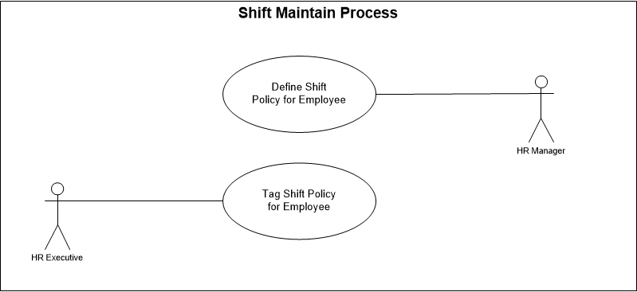

Fig: Shift Maintain Process use case

## Holiday Maintain Process:

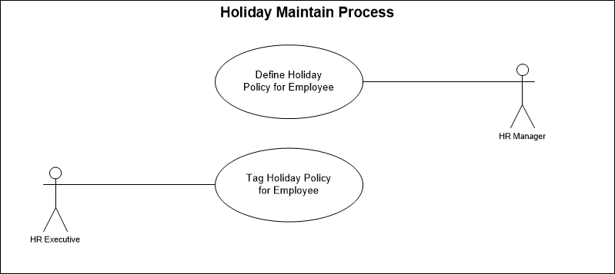

Fig: Holiday Maintain Process use case

## Leave Maintain Process:

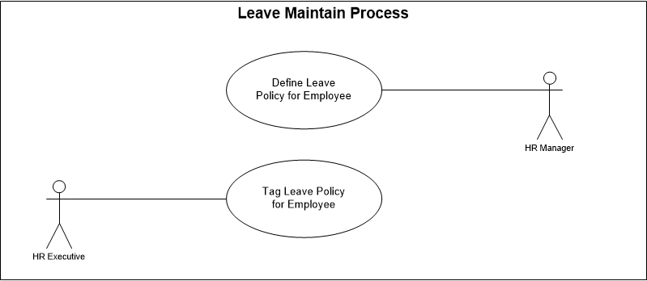

Fig: Leave Maintain Process use case

## Absenteeism Maintain Process:

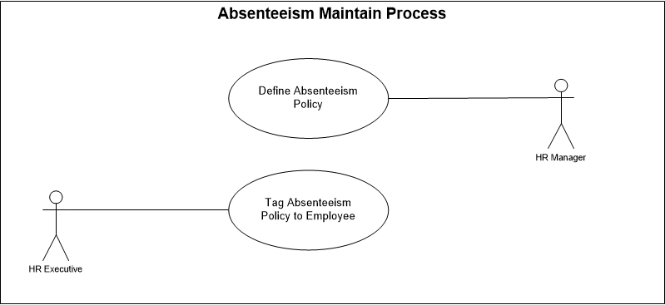

Fig: Absenteeism Maintain Process use case

## Late Present Maintain Process:

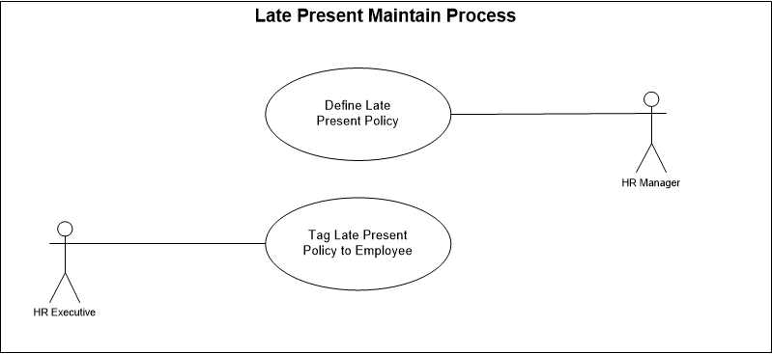

Fig: Late Present Maintain Process use case

## Disciplinary Action Process:

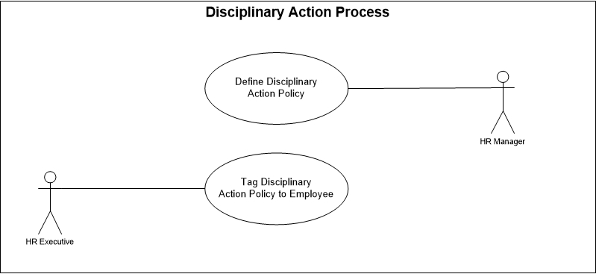

Fig: Disciplinary Action Process use case

## Attendance Bonus Process:

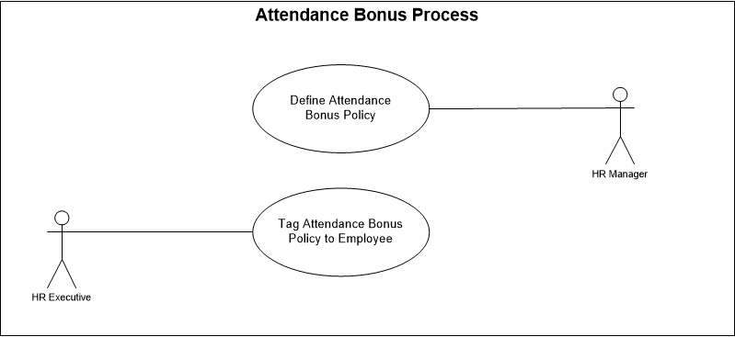

Fig: Attendance Bonus Process use case

## Festival Bonus Process:

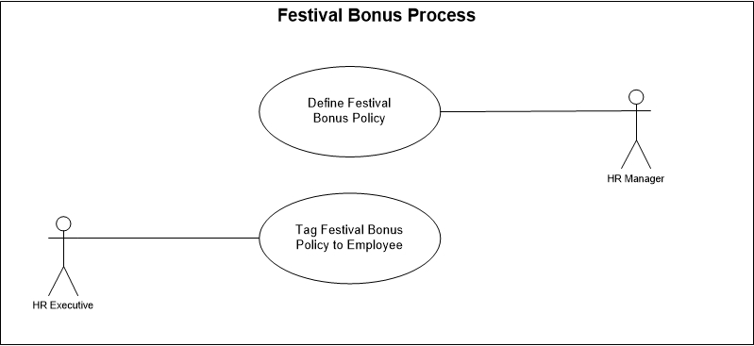

Fig: Festival Bonus Process use case

## Performance Bonus Process:

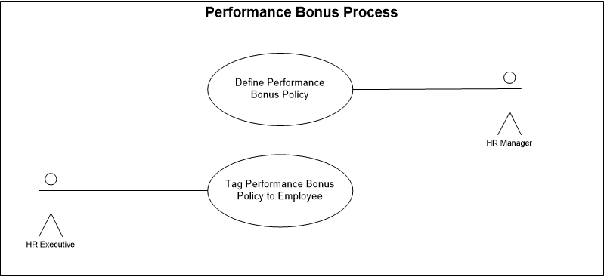

Fig: Performance Bonus Process use case

## Appraisal Process:

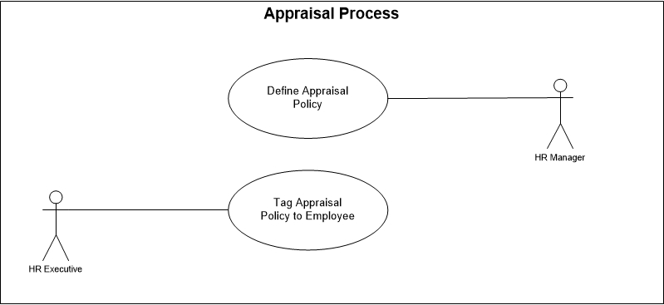

Fig: Appraisal Process use case

## Employee Blacklisting Process:

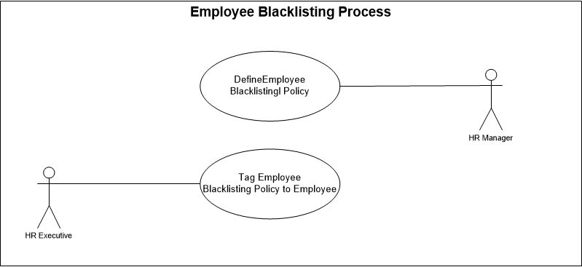

Fig: Employee Blacklisting Process use case

## Salary Process:

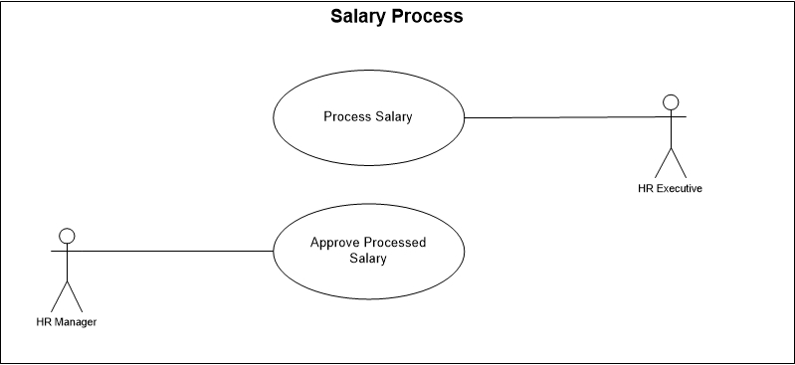

Fig: Salary Process use case

# USE CASE Details

## UC/HRMS/001/Declaration of Departments & Sections:

|  |  |  |
| --- | --- | --- |
| Use Case ID: UC/HRMS/001 | | |
| Use Case Name**: Declaration of Departments & Sections** | | |
| Created By: **GenWeb2 Ltd.** | | Date Created: 16 March, 2016 |
| Actors: | * HR Manager | |
| Trigger: | * Setting Departments & Sections for Organization | |
| Business Rule | * HR Manager will declare all the departments and sections of the Organization * Employee (s) will be tagged with the respective Department & Section | |
| Description: | All Departments & Sections need to set for tagging employees to the respective department & section | |
| Frequency of Use | * Medium | |
| Preconditions | * N/A | |
| Post conditions | * Appropriate message will be displayed after each entry being saved / updated. * Departments & Sections will be saved in System | |
| Assumption | * Departments & Sections are already well defined for organization | |
| Goal | Record Departments & Sections details in system. | |
| Normal Flow | * HR manager insert all the Departments & Sections in system | |
| Alternate Flow | * N/A | |
| Exception | * Proper message should be displayed if Departments & Sections can’t be saved. * Proper message should be displayed if any master or dependent data is missing or not found. * Appropriate message should be displayed if mandatory fields are not filled. * Any system exception/Application exception should be handled centrally with proper user message during the page browse/save/update/view operations. | |
| Cross Reference | * N/A | |

## UC/HRMS/002/Declaration of Position:

|  |  |  |
| --- | --- | --- |
| Use Case ID: UC/HRMS/002 | | |
| Use Case Name**: Declaration of Position** | | |
| Created By: **GenWeb2 Ltd.** | | Date Created: 16 March, 2016 |
| Actors: | * HR Manager | |
| Trigger: | * Setting al position for Organization | |
| Business Rule | * HR Manager will declare all the position(s) of the organization * Employee (s) will be tagged with the respective position | |
| Description: | All position of the Organization declaration in system | |
| Frequency of Use | * Medium | |
| Preconditions | * N/A | |
| Post conditions | * Appropriate message will be displayed after each entry being saved / updated. * Position will be saved in System | |
| Assumption | * positions are already well defined for organization | |
| Goal | Record all positions in system. | |
| Normal Flow | * HR manager insert all the Positions in system | |
| Alternate Flow | * N/A | |
| Exception | * Proper message should be displayed if Position can’t be saved. * Proper message should be displayed if any master or dependent data is missing or not found. * Appropriate message should be displayed if mandatory fields are not filled. * Any system exception/Application exception should be handled centrally with proper user message during the page browse/save/update/view operations. | |
| Cross Reference | * N/A | |

## UC/HRMS/003/Declaration Of Organogram:

|  |  |
| --- | --- |
| Use Case ID: UC/HRMS/003 | |
| Use Case Name**: Declaration of Organization** | |
| Created By: **GenWeb2 Ltd.** | Date Created: 16 March, 2016 |
| Actors: | * HR Manager |
| Trigger: | When HR Manager declare the Organogram of Organization in System. |
| Business Rule | * HR Manager will declare the Organogram of the Organization * Every Employee will be tagged as per the declared Organogram |
| Description: | HR Manager will declare the Organogram of the Organization in System so every Employee will be identified by given position in the organogram. |
| Frequency of Use | * Low |
| Preconditions | * N/A |
| Post Conditions | * Appropriate message will be displayed after each entry being saved / updated. * Organogram will be saved in System. |
| Assumption | * N/A |
| Goal | Record Organogram in System |
| Normal Flow | * HR manager define the Organogram in system |
| Alternate Flow | N/A |
| Exception | * Proper message should be displayed if Organogram can’t be saved. * Proper message should be displayed if any master or dependent data is missing or not found. * Appropriate message should be displayed if mandatory fields are not filled. * Any system exception/Application exception should be handled centrally with proper user message during the page browse/save/update/view operations. |
| Cross Reference | * N/A |

## UC/HRMS/004/ Employee Type Declaration:

|  |  |  |
| --- | --- | --- |
| Use Case ID: UC/HRMS/004 | | |
| Use Case Name**: Employee Type Declaration** | | |
| Created By: **GenWeb2 Ltd.** | | Date Created: **16 March 2016** |
| Actors: | HR Manager | |
| Trigger: | When HR Manager declare the type of Employee in System. | |
| Business Rule | * HR Manager will declare the Employee Type * Respective Employee Type will be tagged with Employee | |
| Description: | HR Manager will declare the Type of all employees in System so those type will be tagged with Employee for further respective activities. | |
| Frequency of Use | Medium | |
| Preconditions | * N/A | |
| Post conditions | * Appropriate message will be displayed after each entry being saved / updated. * Employee Type will be saved in System. * Employee Type will be available to select in Employee Details. * Employee will be tagged with the respective declared type | |
| Assumption | * Organization Already in practice of Employee Types | |
| Goal | * To Identify the proper employee based on different type | |
| Normal Flow | * HR Manager will declare the Employee Type * In Employee Details respective Employee Type will be tagged with Employee * Based on type employee will be available for further activities | |
| Alternate Flow | * N/A | |
| Exception | * Proper message should be displayed if Employee Type can’t be saved. * Proper message should be displayed if any master or dependent data is missing or not found. * Appropriate message should be displayed if mandatory fields are not filled. * Any system exception/Application exception should be handled centrally with proper user message during the page browse/save/update/view operations. | |
| Cross Reference | * N/A | |

## UC/HRMS/005/ Employee Recruitment Policy:

|  |  |  |
| --- | --- | --- |
| Use Case ID: UC/HRMS/005 | | |
| Use Case Name**: Employee Recruitment Policy** | | |
| Created By: **GenWeb2 Ltd.** | | Date Created: **16 March 2016** |
| Actors: | HR Manager | |
| Trigger: | When HR Manager declare employee recruitment policy in system. | |
| Business Rule | * HR Manager will declare the Employee Recruitment Policy * Employee will be recruited based on the recruitment policy | |
| Description: | HR Manager will declare the Employee Recruitment Policy and employee will be recruited accordingly followed by the policy. | |
| Frequency of Use | Medium | |
| Preconditions | * N/A | |
| Post conditions | * Appropriate message will be displayed after each entry being saved / updated. * Employee Recruitment Policy will be saved in System. * Recruitment policy will be marked while any employee will be recruited | |
| Assumption | * Organization Already in practice of Employee Recruitment Policy | |
| Goal | * To manage proper Employee Recruitment Policy | |
| Normal Flow | * HR Manager will declare the Employee Recruitment Policy * Respective Policy will be tagged when any Employee will be recruited. | |
| Alternate Flow | * N/A | |
| Exception | * Proper message should be displayed if Employee Recruitment Policy can’t be saved. * Proper message should be displayed if any master or dependent data is missing or not found. * Appropriate message should be displayed if mandatory fields are not filled. * Any system exception/Application exception should be handled centrally with proper user message during the page browse/save/update/view operations. | |
| Cross Reference | * N/A | |

## UC/HRMS/006/ Employee Separation Policy:

|  |  |  |
| --- | --- | --- |
| Use Case ID: UC/HRMS/006 | | |
| Use Case Name**: Employee Separation Policy** | | |
| Created By: **GenWeb2 Ltd.** | | Date Created: **16 March 2016** |
| Actors: | HR Manager | |
| Trigger: | When HR Manager declare employee Separation policy in system. | |
| Business Rule | * HR Manager will declare the Employee Separation Policy * Employee Separation Policy will be available to select while HR manager will separate any Employee | |
| Description: | HR Manager will declare the Employee Separation Policy and employee will be discontinued accordingly followed by the separation policy. | |
| Frequency of Use | Medium | |
| Preconditions | * N/A | |
| Post conditions | * Appropriate message will be displayed after each entry being saved / updated. * Employee Separation Policy will be available to select while HR Manager will separate any Employee | |
| Assumption | * Organization Already in practice of Employee Separation Policy | |
| Goal | * To manage proper Employee Separation | |
| Normal Flow | * HR Manager will declare the Employee Separation Policy * Respective Policy will be tagged when any Employee will be separated | |
| Alternate Flow | * N/A | |
| Exception | * Proper message should be displayed if Employee Separation Policy can’t be saved. * Proper message should be displayed if any master or dependent data is missing or not found. * Appropriate message should be displayed if mandatory fields are not filled. * Any system exception/Application exception should be handled centrally with proper user message during the page browse/save/update/view operations. | |
| Cross Reference | * N/A | |

## UC/HRMS/007/ Shift Planning:

|  |  |  |
| --- | --- | --- |
| Use Case ID: UCD/HRMS/007 | | |
| Use Case Name**: Shift Planning** | | |
| Created By: **GenWeb2 Ltd.** | | Date Created: **16 March 2016** |
| Actors: | HR Manager | |
| Trigger: | When HR Manager Plan shift of the organization in System. | |
| Business Rule | * HR Manager will Plan the Working shift of the Organization * Every Employee will be tagged with the respective Shift | |
| Description: | HR Manager will plan the working shift in System, Every employee must be tagged with the respective working shift. | |
| Frequency of Use | Medium | |
| Preconditions | * N/A | |
| Post conditions | * Appropriate message will be displayed after each entry being saved / updated. * Shift Plan will be saved in System. * Shift (s) will be available to select in Employee Details. * Employee will be tagged with the Tagged Shift | |
| Assumption | * Organization already in practice of shift | |
| Goal | * To maintain proper shift with employee details and activities | |
| Normal Flow | * HR Manager will Plan the Shift * In Employee Details respective shift will be tagged with Employee * Based on shift plan employee will be available for further activities. EX: Attendance | |
| Alternate Flow | * N/A | |
| Exception | * Proper message should be displayed if shift plan can’t be saved. * Proper message should be displayed if any master or dependent data is missing or not found. * Appropriate message should be displayed if mandatory fields are not filled. * Any system exception/Application exception should be handled centrally with proper user message during the page browse/save/update/view operations. | |
| Cross Reference | * N/A | |

## UC/HRMS/008/ Declare Weekend & Holiday Policy:

|  |  |  |
| --- | --- | --- |
| Use Case ID: UCD/HRMS/008 | | |
| Use Case Name**: Declare Weekend & Holiday Policy** | | |
| Created By: **GenWeb2 Ltd.** | | Date Created: **16 March 2016** |
| Actors: | HR Manager | |
| Trigger: | When HR Manager Declare Weekend, Holiday & Policy of the organization in System. | |
| Business Rule | * HR Manager will declare the Weekend & Holiday Policy of the organization * Every Employee will be tagged with the respective Weekend & Holiday Policy | |
| Description: | HR Manager will declare the Weekend & Holiday Policy in System, Every employee must be tagged with the respective Weekend & Holiday Policy. | |
| Frequency of Use | Medium | |
| Preconditions | * N/A | |
| Post conditions | * Appropriate message will be displayed after each entry being saved / updated. * Weekend & Holiday Policy will be saved in System. * Weekend & Holiday Policy (s) will be available to select in Employee Details. * Employee will be tagged with the Tagged Weekend & Holiday Policy | |
| Assumption | * Organization already in practice of Weekend & Holiday Policy | |
| Goal | * To maintain proper Weekend & Holiday Policy for respective employee | |
| Normal Flow | * HR Manager will declare Weekend & Holiday Policy * In Employee Details respective Weekend & Holiday Policy will be tagged with Employee * Based on Weekend & Holiday Policy employee will be available for further activities. EX: Attendance, Leave etc. | |
| Alternate Flow | * N/A | |
| Exception | * Proper message should be displayed if Weekend & Holiday Policy can’t be saved. * Proper message should be displayed if any master or dependent data is missing or not found. * Appropriate message should be displayed if mandatory fields are not filled. * Any system exception/Application exception should be handled centrally with proper user message during the page browse/save/update/view operations. | |
| Cross Reference | * N/A | |

## UC/HRMS/009/ Declare Leave Rule & Policy:

|  |  |  |
| --- | --- | --- |
| Use Case ID: UC/HRMS/009 | | |
| Use Case Name**: Declare Leave Rule & Policy** | | |
| Created By: **GenWeb2 Ltd.** | | Date Created: **16 March 2016** |
| Actors: | HR Manager | |
| Trigger: | When HR Manager Declare Leave Rule & Policy of the organization in System. | |
| Business Rule | * HR Manager will declare the Leave Rule & Policy of the organization * Every Employee will be tagged with the respective Leave Rule & Policy | |
| Description: | HR Manager will declare the Leave Rule & Policy in System, Every employee must be tagged with the respective Leave Rule & Policy. | |
| Frequency of Use | Medium | |
| Preconditions | * N/A | |
| Post conditions | * Appropriate message will be displayed after each entry being saved / updated. * Leave Rule & Policy will be saved in System. * Leave Rule & Policy (s) will be available to select in Employee Details. * Employee will be tagged with the Tagged Leave Rule & Policy | |
| Assumption | * Organization already in practice of Leave Rule & Policy | |
| Goal | * To maintain proper Leave Rule & Policy for respective employee | |
| Normal Flow | * HR Manager will declare Leave Rule & Policy * In Employee Details respective Leave Rule & Policy will be tagged with Employee * Based on Leave Rule & Policy employee will be available for further activities. EX: Attendance, Leave, Absenteeism etc. | |
| Alternate Flow | * N/A | |
| Exception | * Proper message should be displayed if Leave Rule & Policy can’t be saved. * Proper message should be displayed if any master or dependent data is missing or not found. * Appropriate message should be displayed if mandatory fields are not filled. * Any system exception/Application exception should be handled centrally with proper user message during the page browse/save/update/view operations. | |
| Cross Reference | * N/A | |

## UC/HRMS/010/ Declare absenteeism Policy:

|  |  |  |
| --- | --- | --- |
| Use Case ID: UC/HRMS/010 | | |
| Use Case Name**: Declare Absenteeism Policy** | | |
| Created By: **GenWeb2 Ltd.** | | Date Created: **16 March 2016** |
| Actors: | HR Manager | |
| Trigger: | When HR Manager Declare Absenteeism Policy of the organization in System. | |
| Business Rule | * HR Manager will declare the Absenteeism Policy of the organization * Every Employee will be tagged with the respective Absenteeism Policy | |
| Description: | HR Manager will declare the Absenteeism Policy in System, Every employee must be tagged with the respective Absenteeism Policy. | |
| Frequency of Use | Medium | |
| Preconditions | * N/A | |
| Post conditions | * Appropriate message will be displayed after each entry being saved / updated. * Absenteeism Policy will be saved in System. * Absenteeism Policy (s) will be available to select in Employee Details. * Employee will be tagged with the Tagged Absenteeism Policy | |
| Assumption | * Organization already in practice of Absenteeism Policy | |
| Goal | * To maintain proper Absenteeism Policy for respective employee | |
| Normal Flow | * HR Manager will declare Absenteeism Policy * In Employee Details respective Absenteeism Policy will be tagged with Employee * Based on Absenteeism Policy employee will be available for further activities. EX: Attendance, Absenteeism etc. | |
| Alternate Flow | * N/A | |
| Exception | * Proper message should be displayed if Absenteeism Policy can’t be saved. * Proper message should be displayed if any master or dependent data is missing or not found. * Appropriate message should be displayed if mandatory fields are not filled. * Any system exception/Application exception should be handled centrally with proper user message during the page browse/save/update/view operations. | |
| Cross Reference | * N/A | |

## UC/HRMS/011/ Declare Overtime Policy:

|  |  |  |
| --- | --- | --- |
| Use Case ID: UC/HRMS/011 | | |
| Use Case Name**: Declare Overtime Policy** | | |
| Created By: **GenWeb2 Ltd.** | | Date Created: **16 March 2016** |
| Actors: | HR Manager | |
| Trigger: | When HR Manager Declare Overtime Policy of the organization in System. | |
| Business Rule | * HR Manager will declare the Overtime Policy of the organization * Every Employee will be tagged with the respective Overtime Policy | |
| Description: | HR Manager will declare the Overtime Policy in System, Every employee must be tagged with the respective Overtime Policy. | |
| Frequency of Use | Medium | |
| Preconditions | * N/A | |
| Post conditions | * Appropriate message will be displayed after each entry being saved / updated. * Overtime Policy will be saved in System. * Overtime Policy (s) will be available to select in Employee Details. * Employee will be tagged with the Tagged Overtime Policy | |
| Assumption | * Organization already in practice of Overtime Policy | |
| Goal | * To maintain proper Overtime Policy for respective employee | |
| Normal Flow | * HR Manager will declare Overtime Policy * In Employee Details respective Overtime Policy will be tagged with Employee * Based on Overtime Policy employee’s overtime benefits will be addressed | |
| Alternate Flow | * N/A | |
| Exception | * Proper message should be displayed if Overtime Policy can’t be saved. * Proper message should be displayed if any master or dependent data is missing or not found. * Appropriate message should be displayed if mandatory fields are not filled. * Any system exception/Application exception should be handled centrally with proper user message during the page browse/save/update/view operations. | |
| Cross Reference | * N/A | |

## UC/HRMS/012/ Declare Late Policy:

|  |  |  |
| --- | --- | --- |
| Use Case ID: UC/HRMS/012 | | |
| Use Case Name**: Declare Late Policy** | | |
| Created By: **GenWeb2 Ltd.** | | Date Created: **16 March, 2016** |
| Actors: | HR Manager | |
| Trigger: | When HR Manager Declare Late Policy of the organization in System. | |
| Business Rule | * HR Manager will declare the Late Policy of the organization * Every Employee will be tagged with the respective Late Policy | |
| Description: | HR Manager will declare the Late Policy in System, Every employee must be tagged with the respective Late Policy. | |
| Frequency of Use | Medium | |
| Preconditions | * N/A | |
| Post conditions | * Appropriate message will be displayed after each entry being saved / updated. * Late Policy will be saved in System. * Late Policy (s) will be available to select in Employee Details. * Employee will be tagged with the Tagged Late Policy | |
| Assumption | * Organization already in practice of Late Policy | |
| Goal | * To maintain proper Late Policy for respective employee | |
| Normal Flow | * HR Manager will declare Late Policy * In Employee Details respective Late Policy will be tagged with Employee * Based on Late Policy employee will be available for further activities. EX: Attendance, Absenteeism, Disciplinary Action etc. | |
| Alternate Flow | * N/A | |
| Exception | * Proper message should be displayed if Late Policy can’t be saved. * Proper message should be displayed if any master or dependent data is missing or not found. * Appropriate message should be displayed if mandatory fields are not filled. * Any system exception/Application exception should be handled centrally with proper user message during the page browse/save/update/view operations. | |
| Cross Reference | * N/A | |

## UC/HRMS/013/ Disciplinary Action Policy:

|  |  |  |
| --- | --- | --- |
| Use Case ID: UC/HRMS/013 | | |
| Use Case Name**: Disciplinary Action Policy** | | |
| Created By: **GenWeb2 Ltd.** | | Date Created: **16 March, 2016** |
| Actors: | HR Manager | |
| Trigger: | When HR Manager Declare Disciplinary Action policy. | |
| Business Rule | * HR Manager will declare the Disciplinary Action Policy of the organization * For Disciplinary Action Employee will be tagged with the Disciplinary Action Policy | |
| Description: | HR Manager will declare the Disciplinary Action Policy in System. For taking disciplinary action against any Employee this disciplinary action policy will be tagged. | |
| Frequency of Use | Medium | |
| Preconditions | * N/A | |
| Post conditions | * Appropriate message will be displayed after each entry being saved / updated. * Disciplinary Action Policy will be saved in System. * Disciplinary action policy will be available wile applying to any Employee for disciplinary Action | |
| Assumption | * Organization already in practice of Disciplinary Action Policy | |
| Goal | * To maintain proper Disciplinary Action Policy for employee | |
| Normal Flow | * HR Manager will declare Disciplinary Action Policy * For taking disciplinary action against any Employee this disciplinary action policy will be tagged. | |
| Alternate Flow | * N/A | |
| Exception | * Proper message should be displayed if Disciplinary Action Policy can’t be saved. * Proper message should be displayed if any master or dependent data is missing or not found. * Appropriate message should be displayed if mandatory fields are not filled. * Any system exception/Application exception should be handled centrally with proper user message during the page browse/save/update/view operations. | |
| Cross Reference | * N/A | |

## UC/HRMS/014/ Declare Pay Grade:

|  |  |  |
| --- | --- | --- |
| Use Case ID: UC/HRMS/014 | | |
| Use Case Name**: Declare Pay Grade** | | |
| Created By: **GenWeb2 Ltd.** | | Date Created: **16 March, 2016** |
| Actors: | HR Manager | |
| Trigger: | When HR Manager Declare Pay Grade of the organization in System. | |
| Business Rule | * HR Manager will declare the Pay Grade of the organization * Every Employee will be tagged with the appropriate Pay Grade | |
| Description: | HR Manager will declare the Pay Grade in System, Every employee must be tagged with the respective Pay Grade. | |
| Frequency of Use | Medium | |
| Preconditions | * N/A | |
| Post conditions | * Appropriate message will be displayed after each entry being saved / updated. * Pay Grade (s) will be saved in System. * Pay Grade (s) will be available to select in Employee Details. * Employee will be tagged with the Tagged Pay Grade | |
| Assumption | * Organization already in practice of Pay Grade | |
| Goal | * To maintain proper Payroll policy for respective employee | |
| Normal Flow | * HR Manager will declare Pay Grade * In Employee Details respective Pay Grade will be tagged with Employee * Based on Pay Grade employee Payroll will be processed | |
| Alternate Flow | * N/A | |
| Exception | * Proper message should be displayed if Pay Grade can’t be saved. * Proper message should be displayed if any master or dependent data is missing or not found. * Appropriate message should be displayed if mandatory fields are not filled. * Any system exception/Application exception should be handled centrally with proper user message during the page browse/save/update/view operations. | |
| Cross Reference | * N/A | |

## UC/HRMS/015/ Declare Grade Step:

|  |  |  |
| --- | --- | --- |
| Use Case ID: UC/HRMS/015 | | |
| Use Case Name**: Request Rework** | | |
| Created By: **GenWeb2 Ltd.** | | Date Created: **16 March, 2016** |
| Actors: | HR Manager | |
| Trigger: | When HR Manager Declare Grade Step of the organization in System. | |
| Business Rule | * HR Manager will declare the Grade Step of the organization * Every Employee will be tagged with the appropriate Grade Step under the Pay Grade | |
| Description: | HR Manager will declare the Grade Step in System, Every employee must be tagged with the respective Grade Step under Pay Grade. | |
| Frequency of Use | Medium | |
| Preconditions | N/A | |
| Post conditions | * Appropriate message will be displayed after each entry being saved / updated. * Grade Step (s) will be saved in System. * Grade Step (s) will be available to select in Employee Details. * Employee will be tagged with the Tagged Grade Step under Pay Grade | |
| Assumption | Organization already in practice of Grade Step under Pay Grade | |
| Goal | To maintain proper Payroll policy for respective employee | |
| Normal Flow | * HR Manager will declare Grade Step * In Employee Details respective Grade Step under Pay Grade will be tagged with Employee * Based on Grade Step under Pay Grade employee Payroll will be processed | |
| Alternate Flow | * N/A | |
| Exception | * Proper message should be displayed if Grade Step can’t be saved. * Proper message should be displayed if any master or dependent data is missing or not found. * Appropriate message should be displayed if mandatory fields are not filled. * Any system exception/Application exception should be handled centrally with proper user message during the page browse/save/update/view operations. | |
| Cross Reference | * N/A | |

## UC/HRMS/016/ Declare Pay Band:

|  |  |  |
| --- | --- | --- |
| Use Case ID: UC/HRMS/016 | | |
| Use Case Name**: Declare Pay Band** | | |
| Created By: **GenWeb2 Ltd.** | | Date Created: **16 March, 2016** |
| Actors: | HR Manager | |
| Trigger: | When HR Manager Declare Pay Band of the organization in System. | |
| Business Rule | * HR Manager will declare the Pay Band of the organization * Every Employee will be tagged with the appropriate Pay Band | |
| Description: | HR Manager will declare the Pay Band in System, Every employee must be tagged with the respective Pay Band. | |
| Frequency of Use | Medium | |
| Preconditions | N/A | |
| Post conditions | * Appropriate message will be displayed after each entry being saved / updated. * Pay Band will be saved in System. * Pay Band will be available to select in Employee Details. * Employee will be tagged with the Tagged Pay Band | |
| Assumption | Organization already in practice of Pay Band | |
| Goal | To maintain proper Payroll policy for respective employee | |
| Normal Flow | * HR Manager will declare Pay Band * In Employee Details respective Pay Band will be tagged with Employee * Based on Pay Band employee Payroll will be processed | |
| Alternate Flow | * N/A | |
| Exception | * Proper message should be displayed if Pay band can’t be saved. * Proper message should be displayed if any master or dependent data is missing or not found. * Appropriate message should be displayed if mandatory fields are not filled. * Any system exception/Application exception should be handled centrally with proper user message during the page browse/save/update/view operations. | |
| Cross Reference | * N/A | |

## UC/HRMS/017/ Declare Attendance Bonus Policy:

|  |  |  |
| --- | --- | --- |
| Use Case ID: UC/HRMS/017 | | |
| Use Case Name**: Declare Attendance Bonus Policy** | | |
| Created By: **GenWeb2 Ltd.** | | Date Created: **16 March, 2015** |
| Actors: | HR Manager | |
| Trigger: | When HR Manager Declare Attendance Bonus Policy of the organization in System. | |
| Business Rule | * HR Manager will declare the Attendance Bonus Policy of the organization * Employee will be tagged with the respective attendance Bonus policy | |
| Description: | HR Manager will declare the Attendance Bonus Policy in System, Every employee must be tagged with the respective Attendance Bonus Policy. | |
| Frequency of Use | Medium | |
| Preconditions | N/A | |
| Post conditions | * Appropriate message will be displayed after each entry being saved / updated. * Attendance Bonus Policy will be saved in System. * Attendance Bonus Policy will be available to select in Employee Details. * Employee will be tagged with the Attendance Bonus Policy | |
| Assumption | Organization already in practice of Attendance Bonus Policy | |
| Goal | To maintain proper Payroll policy for respective employee | |
| Normal Flow | * HR Manager will declare Attendance Bonus Policy * In Employee Details respective Attendance Bonus Policy will be tagged with Employee * Based on Attendance Bonus Policy employee Payroll will be processed | |
| Alternate Flow | * N/A | |
| Exception | * Proper message should be displayed if Attendance Bonus Policy can’t be saved. * Proper message should be displayed if any master or dependent data is missing or not found. * Appropriate message should be displayed if mandatory fields are not filled. * Any system exception/Application exception should be handled centrally with proper user message during the page browse/save/update/view operations. | |
| Cross Reference | * N/A | |

## UC/HRMS/018/ Record Employees Personal Information:

|  |  |  |
| --- | --- | --- |
| Use Case ID: UC/HRMS/018 | | |
| Use Case Name**: Record Employees Personal Information** | | |
| Created By: **GenWeb2 Ltd.** | | Date Created: **16 March, 2016** |
| Actors: | HR Executive | |
| Trigger: | When HR Executive enter the Employee information details in system. | |
| Business Rule | * HR Executive will enter the Employee information in details in system. * Employees Personal Information and payroll will be processed based on the entered information details | |
| Description: | HR Executive will enter the employee information in details in System, Like Shift, Leave policy, pay band etc. and Employees Personal Information and Payroll as per the given information. | |
| Frequency of Use | Medium | |
| Preconditions | N/A | |
| Post conditions | * Appropriate message will be displayed after each entry being saved / updated. * Employee Information will be saved in System. * Employee will be tagged with the marked policies. | |
| Assumption | Organization already in practice of Employee Personal Information | |
| Goal | To maintain proper Employee Personal Information for respective employee | |
| Normal Flow | * HR Executive will enter all the Persona Information of the Employee * Employee will be tagged with the given policies | |
| Alternate Flow | * N/A | |
| Exception | * Proper message should be displayed if Employee details can’t be saved. * Proper message should be displayed if any master or dependent data is missing or not found. * Appropriate message should be displayed if mandatory fields are not filled. * Any system exception/Application exception should be handled centrally with proper user message during the page browse/save/update/view operations. | |
| Cross Reference | * N/A | |

## UC/HRMS/019/ Tagging Employee to Department & Section:

|  |  |  |
| --- | --- | --- |
| Use Case ID: UC/HRMS/019 | | |
| Use Case Name**: Tagging Employee to Department & Section** | | |
| Created By: **GenWeb2 Ltd.** | | Date Created: **16 September, 2016** |
| Actors: | HR Executive | |
| Trigger: | When HR Executive tag any employee to respective Department & Section. | |
| Business Rule | * HR Executive will tag any employee to the respective Department & Section * Employees Personal Information will be tagged with the respective Department & Section. * Employee will be found for any activities under the respective department only. | |
| Description: | HR Executive tag any employee to his/her respective Department & Section so that particular employee will be available for any further activities under that department & Section | |
| Frequency of Use | Medium | |
| Preconditions | * Employee Must Exist * Department & Section Must Exist | |
| Post conditions | * Appropriate message will be displayed after each entry being saved / updated. * Employee Information will be tagged with the given department & Section and will be saved in System. * Employee will be found for any further activities under that department & Section | |
| Assumption | Organization already in practice of tagging employee with Department & Section | |
| Goal | To maintain proper Employee by Department & Section | |
| Normal Flow | * HR Executive will tag any employee to the respective Department & Section * Employee will be tagged with the Department & Section * Employee will be available for any further activities under that Department & Section | |
| Alternate Flow | * N/A | |
| Exception | * Proper message should be displayed if Department & Section tagging can’t be saved. * Proper message should be displayed if any master or dependent data is missing or not found. * Appropriate message should be displayed if mandatory fields are not filled. * Any system exception/Application exception should be handled centrally with proper user message during the page browse/save/update/view operations. | |
| Cross Reference | * N/A | |

## UC/HRMS/020/ Declare Position to Employee:

|  |  |  |
| --- | --- | --- |
| Use Case ID: UC/HRMS/020 | | |
| Use Case Name **Marking Position to Employee** | | |
| Created By: **GenWeb2 Ltd.** | | Date Created: **16 March, 2016** |
| Actors: | HR Executive | |
| Trigger: | When HR Executive declare position of any employee | |
| Business Rule | * HR Executive will declare the position of the employee * Employees Personal Information will be tagged with declared position * Employee will get his/her position roll. | |
| Description: | HR Executive declare position of any employee and that employee get the respective position roll | |
| Frequency of Use | Medium | |
| Preconditions | * Employee Must Exist * Position must exist | |
| Post conditions | * Appropriate message will be displayed after each entry being saved / updated. * Employee will be tagged with the position in System. * Employee will enjoy the position roll | |
| Assumption | Organization already in practice of employee Position | |
| Goal | To maintain employee properly by position | |
| Normal Flow | * HR Executive will tag any employee his/her position * Employee will be tagged with the position * Employee will get the position roll | |
| Alternate Flow | * N/A | |
| Exception | * Proper message should be displayed if Employee position can’t be saved. * Proper message should be displayed if any master or dependent data is missing or not found. * Appropriate message should be displayed if mandatory fields are not filled. * Any system exception/Application exception should be handled centrally with proper user message during the page browse/save/update/view operations. | |
| Cross Reference | * N/A | |

## UC/HRMS/021/ Tagging Shift to Employee:

|  |  |  |
| --- | --- | --- |
| Use Case ID: UC/HRMS/021 | | |
| Use Case Name**: Tagging Shift to Employee** | | |
| Created By: **GenWeb2 Ltd.** | | Date Created: **16 March, 2016** |
| Actors: | HR Executive | |
| Trigger: | When HR Executive tag employee to his/her respective shift | |
| Business Rule | * HR Executive will tag any employee with his/her respective shift * Employees will be tagged with the declared shift * Employee will be available for any further activities under that tagged shift | |
| Description: | HR Executive tag any employee to his/her shift and that employee will be available for any further activities under that shift | |
| Frequency of Use | Medium | |
| Preconditions | * Employee Must Exist * Shift must exist | |
| Post conditions | * Appropriate message will be displayed after each entry being saved / updated. * Employee will be tagged with the shift in System. * Employee will be available for any further activities under that shift | |
| Assumption | Organization already in practice of shift | |
| Goal | To maintain employee properly by shift | |
| Normal Flow | * HR Executive will tag any employee his/her shift * Employee will be tagged with the shift * Employee will be available for any further activities under that declared shift | |
| Alternate Flow | * N/A | |
| Exception | * Proper message should be displayed if Employee shift tagging can’t be saved. * Proper message should be displayed if any master or dependent data is missing or not found. * Appropriate message should be displayed if mandatory fields are not filled. * Any system exception/Application exception should be handled centrally with proper user message during the page browse/save/update/view operations. | |
| Cross Reference | * N/A | |

## 

## UC/HRMS/022/ Tagging Holiday Policy to Employee:

|  |  |  |
| --- | --- | --- |
| Use Case ID: UC/HRMS/022 | | |
| Use Case Name**: Tagging Holiday Policy to Employee** | | |
| Created By: **GenWeb2 Ltd.** | | Date Created: **16 March, 2016** |
| Actors: | HR Executive | |
| Trigger: | When HR Executive tag employee to his/her respective Holiday Policy | |
| Business Rule | * HR Executive will tag any employee with his/her respective Holiday Policy * Employees will be tagged with the respective Holiday Policy * Employee attendance will be maintained by the holiday policy | |
| Description: | HR Executive tag any employee to his/her Holiday policy and that employee’s attendance and task plan will be managed accordingly based on that holiday policy | |
| Frequency of Use | Medium | |
| Preconditions | * Employee Must Exist * Holiday Policy must exist | |
| Post conditions | * Appropriate message will be displayed after each entry being saved / updated. * Employee will be tagged with the holiday policy in system. * Employee’s attendance will be managed based on the tagged holiday policy | |
| Assumption | Organization already in practice of holiday policy | |
| Goal | To maintain Proper holiday policy for employee | |
| Normal Flow | * HR Executive will tag any employee his/her holiday policy * Employee will be tagged with the holiday policy * Employee’s attendance will be managed based on that holiday policy | |
| Alternate Flow | * N/A | |
| Exception | * Proper message should be displayed if Employee’s holiday policy tagging can’t be saved. * Proper message should be displayed if any master or dependent data is missing or not found. * Appropriate message should be displayed if mandatory fields are not filled. * Any system exception/Application exception should be handled centrally with proper user message during the page browse/save/update/view operations. | |
| Cross Reference | * N/A | |

## UC/HRMS/023/ Tagging Leave Rule to Employee:

|  |  |  |
| --- | --- | --- |
| Use Case ID: UC/HRMS/023 | | |
| Use Case Name**: Tagging Leave Rule to Employee** | | |
| Created By: **GenWeb2 Ltd.** | | Date Created: **16 March, 2016** |
| Actors: | HR Executive | |
| Trigger: | When HR Executive tag employee to his/her respective Leave Rule | |
| Business Rule | * HR Executive will tag any employee with his/her respective Leave Rule * Employees will be tagged with the respective Leave Rule * Employee attendance & Absenteeism will be maintained by the Leave Rule | |
| Description: | HR Executive tag any employee to his/her Leave Rule and that employee’s attendance & Absenteeism will be managed accordingly based on that Leave Rule | |
| Frequency of Use | Medium | |
| Preconditions | * Employee Must Exist * Leave Rule must exist | |
| Post conditions | * Appropriate message will be displayed after each entry being saved / updated. * Employee will be tagged with the Leave Rule in system. * Employee’s attendance will be managed based on the tagged Leave Rule | |
| Assumption | Organization already in practice of Leave Rule | |
| Goal | To maintain Proper Leave Rule & policy for employee | |
| Normal Flow | * HR Executive will tag any employee his/her Leave Rule * Employee will be tagged with the Leave Rule * Employee’s attendance will be managed based on that Leave Rule | |
| Alternate Flow | * N/A | |
| Exception | * Proper message should be displayed if Employee’s Leave Rule tagging can’t be saved. * Proper message should be displayed if any master or dependent data is missing or not found. * Appropriate message should be displayed if mandatory fields are not filled. * Any system exception/Application exception should be handled centrally with proper user message during the page browse/save/update/view operations. | |
| Cross Reference | * N/A | |

## UC/HRMS/024/ Tagging absenteeism Policy to Employee:

|  |  |  |
| --- | --- | --- |
| Use Case ID: UC/HRMS/024 | | |
| Use Case Name**: Tagging absenteeism Policy to Employee** | | |
| Created By: **GenWeb2 Ltd.** | | Date Created: **16 March, 2016** |
| Actors: | HR Executive | |
| Trigger: | When HR Executive tag employee to his/her respective Absenteeism Policy | |
| Business Rule | * HR Executive will tag any employee with his/her respective Absenteeism Policy * Employees will be tagged with the respective Absenteeism Policy * Employee attendance & Absenteeism will be maintained by the Absenteeism Policy | |
| Description: | HR Executive tag any employee to his/her Absenteeism Policy and that employee’s attendance & Absenteeism will be managed accordingly based on that Absenteeism Policy | |
| Frequency of Use | Medium | |
| Preconditions | * Employee Must Exist * Absenteeism Policy must exist | |
| Post conditions | * Appropriate message will be displayed after each entry being saved / updated. * Employee will be tagged with the Absenteeism Policy in system. * Employee’s attendance will be managed based on the tagged Absenteeism Policy | |
| Assumption | Organization already in practice of Absenteeism Policy | |
| Goal | To maintain Proper Absenteeism policy for employee | |
| Normal Flow | * HR Executive will tag any employee his/her Absenteeism Policy * Employee will be tagged with the Absenteeism Policy * Employee’s absenteeism will be managed based on that Absenteeism Policy | |
| Alternate Flow | * N/A | |
| Exception | * Proper message should be displayed if Employee’s Absenteeism Policy tagging can’t be saved. * Proper message should be displayed if any master or dependent data is missing or not found. * Appropriate message should be displayed if mandatory fields are not filled. * Any system exception/Application exception should be handled centrally with proper user message during the page browse/save/update/view operations. | |
| Cross Reference | * N/A | |

## UC/HRMS/025/ Tagging Overtime Policy to Employee:

|  |  |  |
| --- | --- | --- |
| Use Case ID: UC/HRMS/025 | | |
| Use Case Name**: Tagging Overtime Policy to Employee** | | |
| Created By: **GenWeb2 Ltd.** | | Date Created: **16 March, 2016** |
| Actors: | HR Executive | |
| Trigger: | When HR Executive tag employee to his/her respective Overtime Policy | |
| Business Rule | * HR Executive will tag any employee with his/her respective Overtime Policy * Employees will be tagged with the respective Overtime Policy * Employee overtime benefits will be managed based on the tagged overtime policy | |
| Description: | HR Executive tag any employee to his/her Overtime Policy and that employee’s overtime benefits will be managed based on the tagged overtime policy | |
| Frequency of Use | Medium | |
| Preconditions | * Employee Must Exist * Overtime Policy must exist | |
| Post conditions | * Appropriate message will be displayed after each entry being saved / updated. * Employee will be tagged with the Overtime Policy in system. * Employee’s Overtime Benefits will be managed based on the tagged Overtime policy | |
| Assumption | Organization already in practice of Overtime Policy | |
| Goal | To maintain Proper overtime benefits policy for employee | |
| Normal Flow | * HR Executive will tag any employee his/her Overtime Policy * Employee will be tagged with the Overtime Policy * Employee’s overtime benefits will be managed based on the tagged overtime policy | |
| Alternate Flow | * N/A | |
| Exception | * Proper message should be displayed if Employee’s Overtime Policy tagging can’t be saved. * Proper message should be displayed if any master or dependent data is missing or not found. * Appropriate message should be displayed if mandatory fields are not filled. * Any system exception/Application exception should be handled centrally with proper user message during the page browse/save/update/view operations. | |
| Cross Reference | * N/A | |

## UC/HRMS/026/ Tagging Late Policy to employee:

|  |  |  |
| --- | --- | --- |
| Use Case ID: UC/HRMS/026 | | |
| Use Case Name**: Tagging Late Policy to employee** | | |
| Created By: **GenWeb2 Ltd.** | | Date Created: **16 March, 2016** |
| Actors: | HR Executive | |
| Trigger: | When HR Executive tag employee to his/her respective Late Policy | |
| Business Rule | * HR Executive will tag any employee with his/her respective Late Policy * Employees will be tagged with the respective Late Policy * Employee attendance & Late will be maintained by the Late Policy | |
| Description: | HR Executive tag any employee to his/her Late Policy and that employee’s attendance & Late will be managed accordingly based on that Late Policy | |
| Frequency of Use | Medium | |
| Preconditions | * Employee Must Exist * Late Policy must exist | |
| Post conditions | * Appropriate message will be displayed after each entry being saved / updated. * Employee will be tagged with the Late Policy in system. * Employee’s attendance will be managed based on the tagged Late Policy | |
| Assumption | Organization already in practice of Late Policy | |
| Goal | To maintain Proper Late policy for employee | |
| Normal Flow | * HR Executive will tag any employee his/her Late Policy * Employee will be tagged with the Late Policy * Employee’s Late will be managed based on that Late Policy | |
| Alternate Flow | * N/A | |
| Exception | * Proper message should be displayed if Employee’s Late Policy tagging can’t be saved. * Proper message should be displayed if any master or dependent data is missing or not found. * Appropriate message should be displayed if mandatory fields are not filled. * Any system exception/Application exception should be handled centrally with proper user message during the page browse/save/update/view operations. | |
| Cross Reference | * N/A | |

## UC/HRMS/027/ Tagging Attendance Bonus policy to Employee:

|  |  |  |
| --- | --- | --- |
| Use Case ID: UC/HRMS/027 | | |
| Use Case Name**: Tagging Attendance Bonus policy to Employee** | | |
| Created By: **GenWeb2 Ltd.** | | Date Created: **16 March, 2016** |
| Actors: | HR Executive | |
| Trigger: | When HR Executive tag employee to his/her respective Attendance Bonus Policy | |
| Business Rule | * HR Executive will tag any employee with his/her respective Attendance Bonus Policy * Employees will be tagged with the respective Attendance Bonus Policy * Employee attendance Bonus will be maintained by the tagged Attendance Bonus Policy | |
| Description: | HR Executive tag any employee to his/her Attendance Bonus Policy and that employee’s attendance Bonus will be managed accordingly based on that Attendance Bonus Policy | |
| Frequency of Use | Medium | |
| Preconditions | * Employee Must Exist * Attendance Bonus Policy must exist | |
| Post conditions | * Appropriate message will be displayed after each entry being saved / updated. * Employee will be tagged with the Attendance Bonus Policy in system. * Employee’s attendance Bonus will be managed based on the tagged Attendance Bonus Policy | |
| Assumption | Organization already in practice of Attendance Bonus Policy | |
| Goal | To maintain Proper attendance bonus for employee | |
| Normal Flow | * HR Executive will tag any employee his/her attendance bonus Policy * Employee will be tagged with the attendance bonus Policy * Employee’s attendance bonus will be managed based on that attendance bonus Policy | |
| Alternate Flow | * N/A | |
| Exception | * Proper message should be displayed if Employee’s Attendance Bonus Policy tagging can’t be saved. * Proper message should be displayed if any master or dependent data is missing or not found. * Appropriate message should be displayed if mandatory fields are not filled. * Any system exception/Application exception should be handled centrally with proper user message during the page browse/save/update/view operations. | |
| Cross Reference | * N/A | |

## UC/HRMS/028/ Tagging Festival Bonus policy to Employee:

|  |  |  |
| --- | --- | --- |
| Use Case ID: UC/HRMS/028 | | |
| Use Case Name**: Tagging Festival Bonus policy to Employee** | | |
| Created By: **GenWeb2 Ltd.** | | Date Created: **16 March, 2016** |
| Actors: | HR Executive | |
| Trigger: | When HR Executive tag employee to his/her respective Festival Bonus Policy | |
| Business Rule | * HR Executive will tag any employee with his/her respective Festival Bonus Policy * Employees will be tagged with the respective Festival Bonus Policy * Employee Festival Bonus will be maintained by the tagged Festival Bonus Policy | |
| Description: | HR Executive tag any employee to his/her Festival Bonus Policy and that employee’s Festival Bonus will be managed accordingly based on that Festival Bonus Policy | |
| Frequency of Use | Medium | |
| Preconditions | * Employee Must Exist * Festival Bonus Policy must exist | |
| Post conditions | * Appropriate message will be displayed after each entry being saved / updated. * Employee will be tagged with the Festival Bonus Policy in system. * Employee’s Festival Bonus will be managed based on the tagged Festival Bonus Policy | |
| Assumption | Organization already in practice of Festival Bonus Policy | |
| Goal | To maintain Proper festival bonus for employee | |
| Normal Flow | * HR Executive will tag any employee his/her festival bonus Policy * Employee will be tagged with the festival bonus Policy * Employee’s festival bonus will be managed based on that festival bonus Policy | |
| Alternate Flow | * N/A | |
| Exception | * Proper message should be displayed if Employee’s Festival Bonus Policy tagging can’t be saved. * Proper message should be displayed if any master or dependent data is missing or not found. * Appropriate message should be displayed if mandatory fields are not filled. * Any system exception/Application exception should be handled centrally with proper user message during the page browse/save/update/view operations. | |
| Cross Reference | * N/A | |

## UC/HRMS/029/ Tagging Performance Bonus policy to Employee:

|  |  |  |
| --- | --- | --- |
| Use Case ID: UC/HRMS/029 | | |
| Use Case Name**: Tagging Performance Bonus policy to Employee** | | |
| Created By: **GenWeb2 Ltd.** | | Date Created: **16 March, 2016** |
| Actors: | HR Executive | |
| Trigger: | When HR Executive tag employee to his/her respective Performance Bonus Policy | |
| Business Rule | * HR Executive will tag any employee with his/her respective Performance Bonus Policy * Employees will be tagged with the respective Performance Bonus Policy * Employee Performance Bonus will be maintained by the tagged Performance Bonus Policy | |
| Description: | HR Executive tag any employee to his/her Performance Bonus Policy and that employee’s Performance Bonus will be managed accordingly based on that Performance Bonus Policy | |
| Frequency of Use | Medium | |
| Preconditions | * Employee Must Exist * Performance Bonus Policy must exist | |
| Post conditions | * Appropriate message will be displayed after each entry being saved / updated. * Employee will be tagged with the Performance Bonus Policy in system. * Employee’s Performance Bonus will be managed based on the tagged Performance Bonus Policy | |
| Assumption | Organization already in practice of Performance Bonus Policy | |
| Goal | To maintain Proper performance bonus for employee | |
| Normal Flow | * HR Executive will tag any employee his/her Performance bonus Policy * Employee will be tagged with the Performance bonus Policy * Employee’s Performance bonus will be managed based on that Performance bonus Policy | |
| Alternate Flow | * N/A | |
| Exception | * Proper message should be displayed if Employee’s Performance Bonus Policy tagging can’t be saved. * Proper message should be displayed if any master or dependent data is missing or not found. * Appropriate message should be displayed if mandatory fields are not filled. * Any system exception/Application exception should be handled centrally with proper user message during the page browse/save/update/view operations. | |
| Cross Reference | * N/A | |

## 

## UC/HRMS/030/ Plan Appraisal for Employee:

|  |  |  |
| --- | --- | --- |
| Use Case ID: UC/HRMS/030 | | |
| Use Case Name**: Plan Appraisal for Employee** | | |
| Created By: **GenWeb2 Ltd.** | | Date Created: **16 March, 2016** |
| Actors: | HR Manager | |
| Trigger: | When HR Manager Plan appraisal for any employee | |
| Business Rule | * HR Manager will plan appraisal for any employee * Employees appraisal plan will be mapped with the respective employee * HR Manager will be notified based on the planned appraisal of any employee | |
| Description: | HR Manager plan appraisal for any employee so it gat mapped with that employee information and HR Manager will be notified while the appraisal plan time will come so authority can make it happen. | |
| Frequency of Use | Medium | |
| Preconditions | * Employee Must Exist | |
| Post conditions | * Appropriate message will be displayed after each entry being saved / updated. * Appraisal Plan will be mapped with the employee in system. * HR Manager will be notified at the period of the declared appraisal time | |
| Assumption | Organization already in practice of appraisal plan | |
| Goal | To maintain Proper appraisal plan for employee | |
| Normal Flow | * HR Manager plan appraisal for any employee * Planned appraisal will be tagged with the employee information * HR Manager will be notified at the period of the declared appraisal time | |
| Alternate Flow | * N/A | |
| Exception | * Proper message should be displayed if appraisal plan can’t be saved. * Proper message should be displayed if any master or dependent data is missing or not found. * Appropriate message should be displayed if mandatory fields are not filled. * Any system exception/Application exception should be handled centrally with proper user message during the page browse/save/update/view operations. | |
| Cross Reference | * N/A | |

## UC/HRMS/031/ Employee Separation:

|  |  |  |
| --- | --- | --- |
| Use Case ID: UC/HRMS/031 | | |
| Use Case Name**: Employee Separation** | | |
| Created By: **GenWeb2 Ltd.** | | Date Created: **16 March 2016** |
| Actors: | HR Manager | |
| Trigger: | When HR Manager separate any Employee based on the policy. | |
| Business Rule | * HR Manager will separate any Employee from the Organization * Employee will be discontinued based on the selected separation policy | |
| Description: | HR Manager will separate any employee from the organization and employee will be discontinued accordingly followed by the selected separation policy. | |
| Frequency of Use | Medium | |
| Preconditions | * Employee Must Exist * Employee Separation Policy Must Exist | |
| Post conditions | * Appropriate message will be displayed after each entry being saved / updated. * Employee will be separate from the organization * Employee status will be inactive. | |
| Assumption | * Organization Already in practice of Employee Separation by Policy | |
| Goal | * To manage proper Employee Separation by Policy | |
| Normal Flow | * HR Manager will Separate any employee * Separated Employee will be discontinued based on the selected separation policy | |
| Alternate Flow | * N/A | |
| Exception | * Proper message should be displayed if Employee Separation can’t be saved. * Proper message should be displayed if any master or dependent data is missing or not found. * Appropriate message should be displayed if mandatory fields are not filled. * Any system exception/Application exception should be handled centrally with proper user message during the page browse/save/update/view operations. | |
| Cross Reference | * N/A | |

## UC/HRMS/032/ Blacklisting Employee:

|  |  |  |
| --- | --- | --- |
| Use Case ID: UC/HRMS/032 | | |
| Use Case Name**: Blacklisting Employee** | | |
| Created By: **GenWeb2 Ltd.** | | Date Created: **16 March 2016** |
| Actors: | HR Manager | |
| Trigger: | When HR Manager blacklist any employee in the organization. | |
| Business Rule | * HR Manager blacklist any employee in the organization * HR manager mark the blacklist reason * Blacklisted employee can’t rejoin in the organization | |
| Description: | HR Manager will blacklist any employee for respective reason and the employee will not be eligible for rejoin. | |
| Frequency of Use | Medium | |
| Preconditions | * Employee Must Exist | |
| Post conditions | * Appropriate message will be displayed after each entry being saved / updated. * Employee will be separate from the organization * Employee status will be inactive. * System will not allow to rejoin the employee | |
| Assumption | * Organization Already in practice of Employee Blacklisting Policy | |
| Goal | * To manage proper Employee Blacklisting | |
| Normal Flow | * HR Manager blacklist any employee in the organization * HR manager mark the blacklist reason * Blacklisted employee will be separated from the organization * Blacklisted employee can’t rejoin in the organization | |
| Alternate Flow | * N/A | |
| Exception | * Proper message should be displayed if Employee blacklisting can’t be saved. * Proper message should be displayed if any master or dependent data is missing or not found. * Appropriate message should be displayed if mandatory fields are not filled. * Any system exception/Application exception should be handled centrally with proper user message during the page browse/save/update/view operations. | |
| Cross Reference | * N/A | |

## UC/HRMS/033/ Process Salary:

|  |  |  |
| --- | --- | --- |
| Use Case ID: UC/HRMS/033 | | |
| Use Case Name**: Process Salary** | | |
| Created By: **GenWeb2 Ltd.** | | Date Created: **16 March, 2016** |
| Actors: | HR Executive | |
| Trigger: | When HR Executive will process the salary of the employee | |
| Business Rule | * Based on all the rules and policies of the organization and individual Salary will be processed by the instruction of HR Executive * HR Manager will approve the processed salary * Accounts Manager will approve the disbursement of the salary * Accounts Executive will disburse the salary | |
| Description: | Based on all the rules and policies of the organization and individuals system will process the salary automatically by the instruction of HR Executive, HR Manager will approve the processed salary, Accounts Manager will approve the disbursement request and Accounts Executive will disburse the salary accordingly | |
| Frequency of Use | Medium | |
| Preconditions | * Employee Must Exist * All rules and policies must Exist | |
| Post conditions | * Appropriate message will be displayed after each entry being saved / updated. * Salary will be process by using system intelligence * HR Manager will be notified for the approval of the processed salary | |
| Assumption | Organization already in practice of Salary Process | |
| Goal | To maintain Proper Salary process of the Organization | |
| Normal Flow | * Based on all the rules and policies of the organization and individuals system will process the salary automatically by the instruction of HR Executive * HR Manager will approve the processed salary * Accounts Manager will approve the disbursement request * Accounts Executive will disburse the salary accordingly | |
| Alternate Flow | * N/A | |
| Exception | * Proper message should be displayed if system can’t process salary * Proper message should be displayed if any master or dependent data is missing or not found. * Appropriate message should be displayed if mandatory fields are not filled. * Any system exception/Application exception should be handled centrally with proper user message during the page browse/save/update/view operations. | |
| Cross Reference | * N/A | |

# HRMS mock-up

## HRMS master user interface mock-up

### Declare Departments:

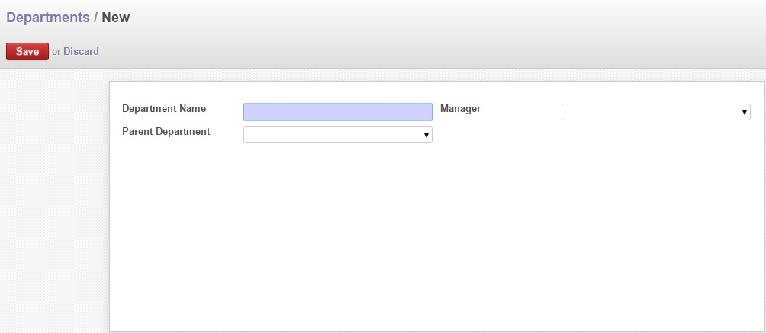

Fig: Declare Departments

### Define Job Position:

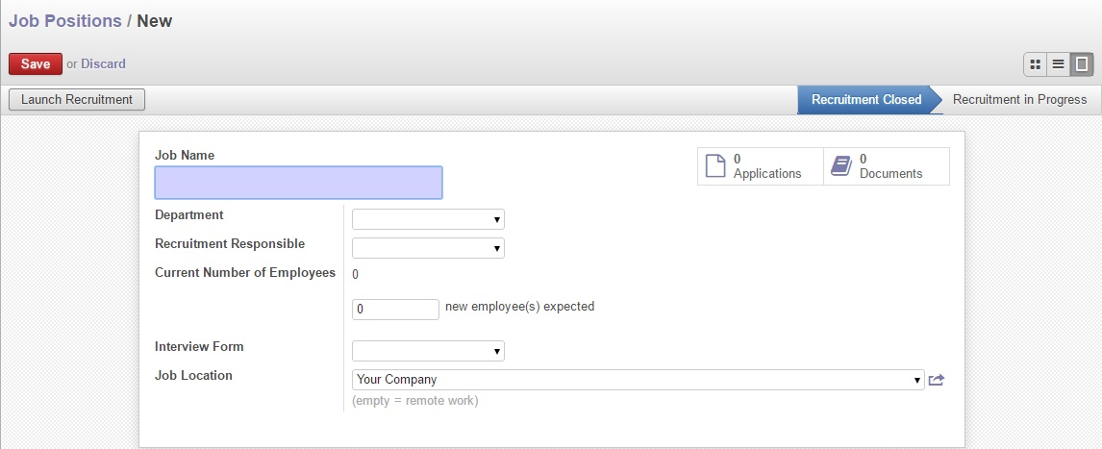

Fig: Define Job Position

### Appraisal Plan:

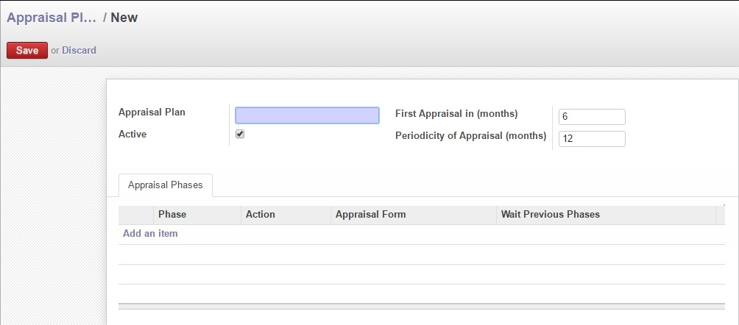

Fig: Appraisal Plan

### Define Leave Policy:

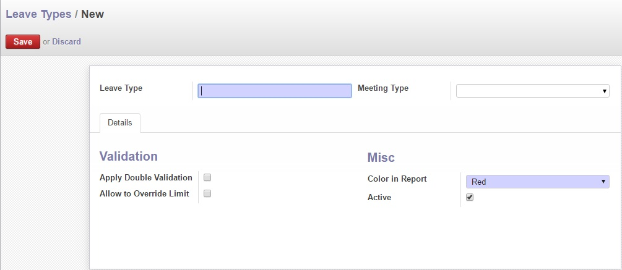

Fig: Define Leave Type & Policy

## Production Planning Operational user interface mock-up

### Employee Basic Information

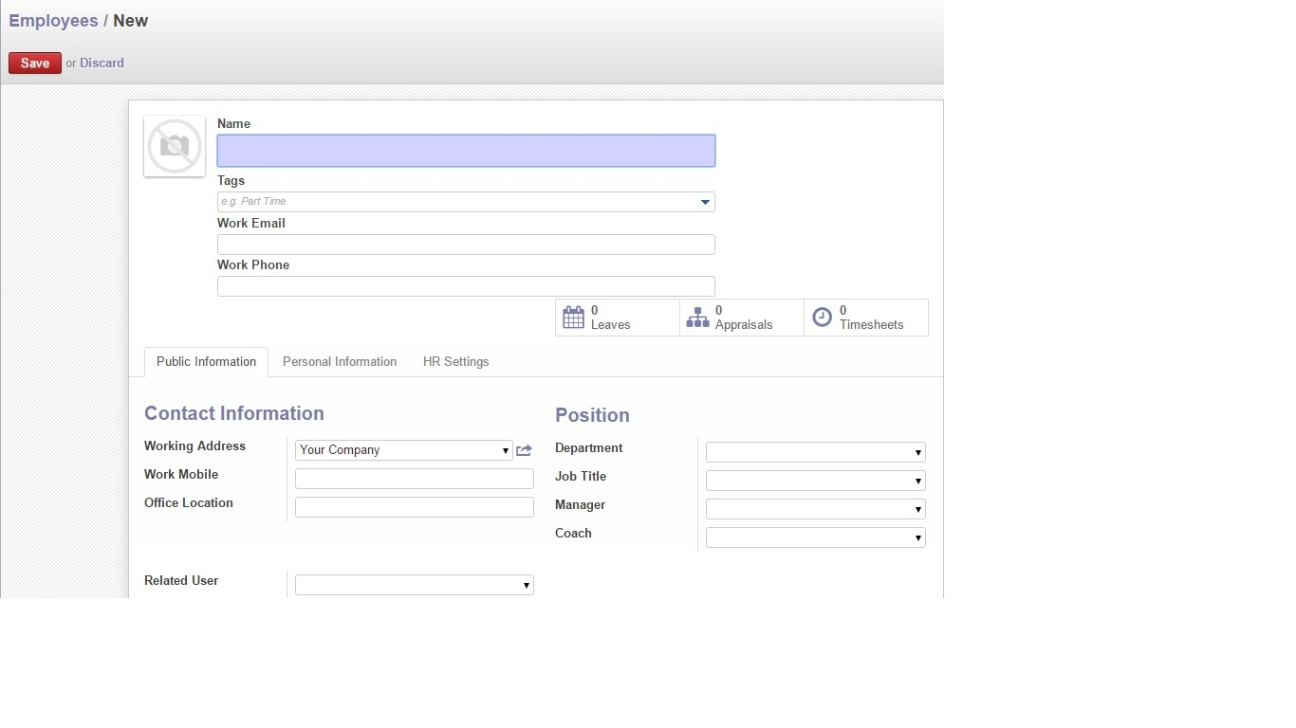

Fig: Employee Basic Information

### Employee Personal Information

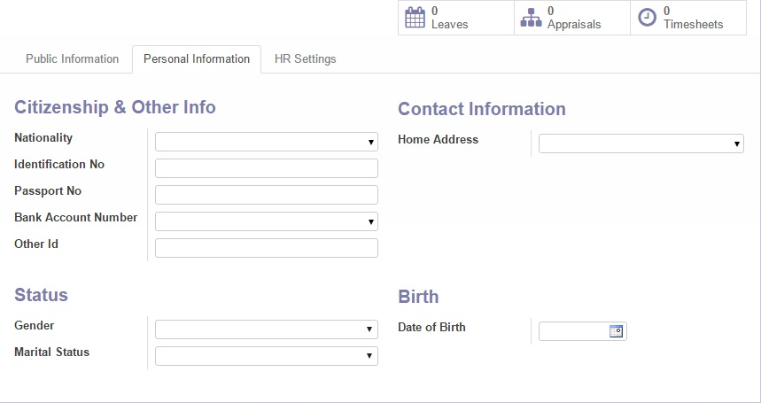

Fig: Employee Personal Information

### Employee HR policy Tagging

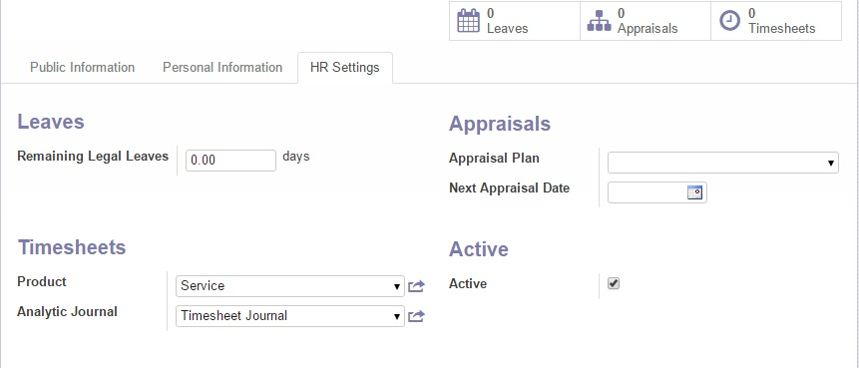

Fig: Employee HR policy Tagging